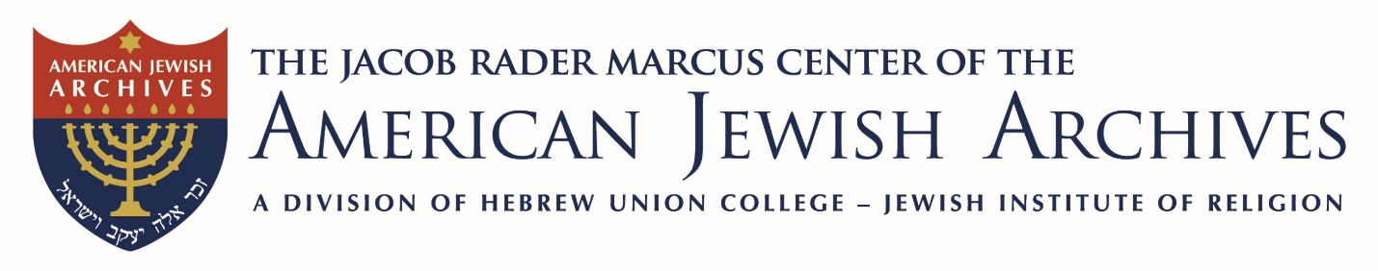
2026–2027 Fellows

Ellie Ash, PhD
Indiana University-Purdue University
The Herbert R. Bloch Jr. Memorial Fellowship
Havurah and the Diffusion of Jewish Feminism After 1975

Elazar Ben-Lulu, PhD
Ariel University
The Jack, Joseph & Morton Mandel Fellowship
Dynamic Peoplehood: American Jewish Responses to Israeli Wars

Jenny Caplan, PhD
University of Cincinnati
The Bernard & Audre Rapoport Fellowship
Jewish Characters in the DC and Marvel Universe

Rabbi Philip Cohen
Independent Scholar
The Loewenstein-Wiener Fellowship
An Intellectual History of American Reform Jewish Thought

Oskar Czendze, PhD
University of Toronto
The Joseph & Eva R. Dave Fellowship
The Habsburg Empire and its Legacy in American Jewish Culture

Ms. Kyra Dezjot
Fordham University
The Loewenstein-Wiener Fellowship
Jewish Opposition to German American Bund Summer Camps

Kirsten Fermaglich, PhD
Michigan State University
The Sy Syms Fellowship
Jews in Academia, Gender, and Internal Migration in the U.S. After World War II

Francesca Freeman
University of Notre Dame
The American Council for Judaism Fellowship
American Zionism & Palestine, 1912–1929

Rabbi Ben Gurin
Boston University
The Rabbi Amy & Gary Perlin Fellowship
Philosophy of Halakha in Reform Judaism

Gustavo Guzman, PhD
Free University of Berlin
The Rabbi Theodore S. Levy Tribute Fellowship
Jewish Responses to Antisemitism in Latin America and the Caribbean, 1917–1991

Clarence Jefferson Hall, Jr., PhD
Queensborough Community College/CUNY
The Loewenstein-Wiener Fellowship
Environmental History of the New York City Jailing Complex at Riker’s Island

Mary Juzwik, PhD
Michigan State University
The Marguerite R. Jacobs Memorial Fellowship
Elie Wiesel’s Night and Secondary English Language Arts Curriculum

Ms. Ellen Kowitt
JewishGen
The Martha Berg Fellowship
Survey of Synagogue Records with Genealogical Value

Geoffrey Levin, PhD
Emory University
The American Council for Judaism Fellowship
American Jews and Middle Eastern Jewish Dilemmas, 1941–1979

Johann Nicolai, PhD
Independent Scholar
The Bernard & Audre Rapoport Fellowship
Transnational Network of B’nai B’rith in Interwar East Central Europe

Gil Ribak, PhD
University of Arizona
The Joseph & Eva R. Dave Fellowship
Self-Censorship in Jewish Culture in a Historical Perspective

Mr. David Selis
Yeshiva University
The Jack, Joseph & Morton Mandel Fellowship
Jewish Libraries and the Creation of American Culture

Haim Sperber, PhD
Western Galilee College
The Jack, Joseph & Morton Mandel Fellowship
Agunot in America, 1870–1914

David Tal, PhD
University of Sussex
The Jack, Joseph & Morton Mandel Fellowship
American Jews Between Israel and the United States

Rebecca Wartell, PhD
Earlham College
The Bernard & Audre Rapoport Fellowship
Conversas in Contrast: Reading Women in Mexican Inquisition Sources

Rabbi Danny Zemel
Temple Micah, Washington, DC
The Rabbi Theodore S. Levy Tribute Fellowship
The Life of Solomon Goldman

